**Topics: Normal distribution, Functions of Random Variables**

1. The time required for servicing transmissions is normally distributed with *μ* = 45 minutes and *σ* = 8 minutes. The service manager plans to have work begin on the transmission of a customer’s car 10 minutes after the car is dropped off and the customer is told that the car will be ready within 1 hour from drop-off. What is the probability that the service manager cannot meet his commitment?
2. 0.3875
3. 0.2676
4. 0.5
5. 0.6987

**Answer: B**

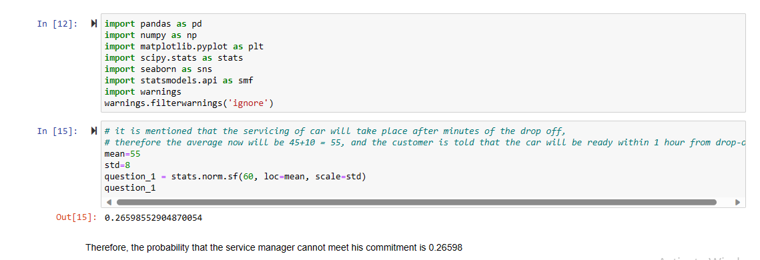

1. The current age (in years) of 400 clerical employees at an insurance claims processing center is normally distributed with mean *μ* = 38 and Standard deviation *σ* =6. For each statement below, please specify True/False. If false, briefly explain why.
2. More employees at the processing center are older than 44 than between 38 and 44.
3. A training program for employees under the age of 30 at the center would be expected to attract about 36 employees.

**Answer:**

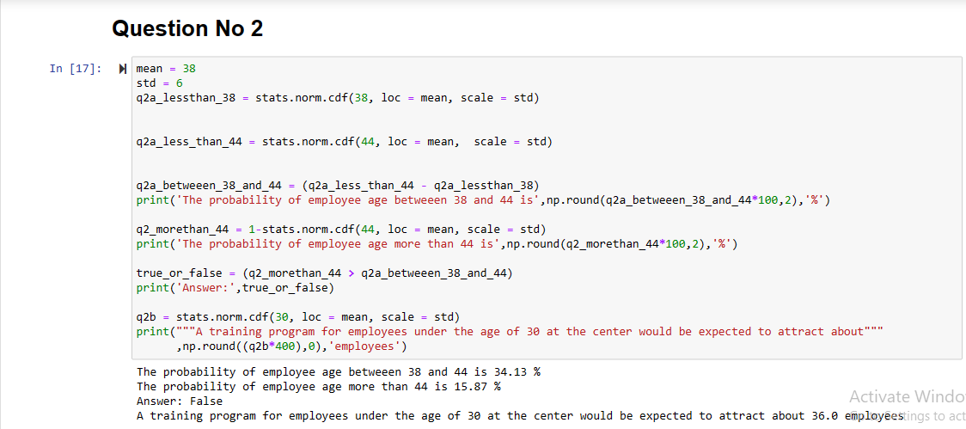

1. **False** - because the percentage share of people between 38 and 44 is 34.13% as against the people above 44 with percentage share of 15.87%. Hence the statement is false.
2. **True.**
3. If *X1* ~ *N*(μ, σ2) and *X*2 ~ *N*(μ, σ2) are *iid* normal random variables, then what is the difference between 2 *X*1 and *X*1 + *X*2? Discuss both their distributions and parameters.

**Answer:**

* For 2X1:

If X1 ~ N(μ, σ^2), then 2X1 follows a normal distribution with the following parameters:

- Mean: 2μ

- Variance: (2*2)σ^2 = 4σ^2

So, 2X1 ~ N(2μ, 4σ^2).

* For distribution of X1 + X2:

If X1 and X2 are iid normal random variables, their sum follows a normal distribution with the following parameters:

- Mean: μ + μ = 2μ

- Variance: σ^2 + σ^2 = 2σ^2

So, X1 + X2 ~ N(2μ, 2σ^2).

Therefore, the variance of 2X1 is four times that of X1 + X2. This means that 2X1 is more spread out than X1 + X2. In terms of mean, they both have the same mean, 2μ.

1. Let X ~ N(100, 202). Find two values, *a* and *b*, symmetric about the mean, such that the probability of the random variable taking a value between them is 0.99.
2. 90.5, 105.9
3. 80.2, 119.8
4. 22, 78
5. 48.5, 151.5
6. 90.1, 109.9

**Answer:** **D**

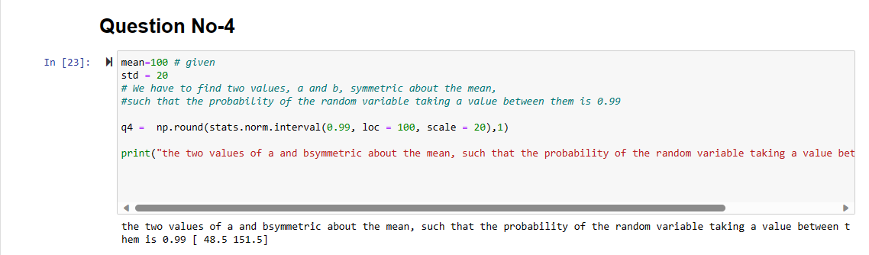

1. Consider a company that has two different divisions. The annual profits from the two divisions are independent and have distributions Profit1 ~ N(5, 32) and Profit2 ~ N(7, 42) respectively. Both the profits are in $ Million. Answer the following questions about the total profit of the company in Rupees. Assume that $1 = Rs. 45
2. Specify a Rupee range (centered on the mean) such that it contains 95% probability for the annual profit of the company.

**Answer:**

95% probability of the annual profit of the company ranges from $2.2 million to $21.8 million

And in Indian rupee it ranges from from 9.90 crore to 98.1 Crore Rupees

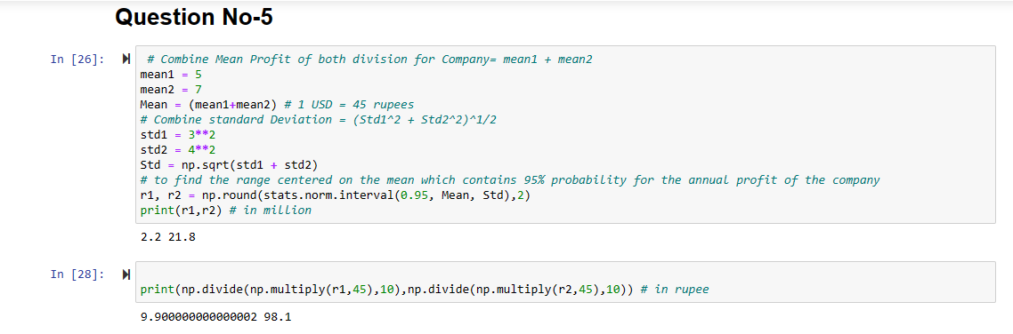

1. Specify the 5th percentile of profit (in Rupees) for the company

**Answer:**

The 5th percentile profit for the company is 17 crore in Indian rupee and in dollar it is $3.78 million

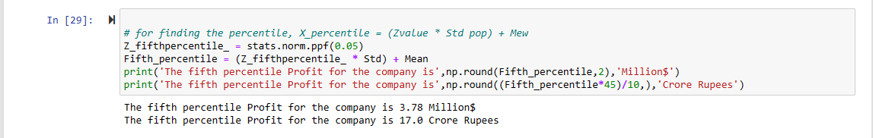

1. Which of the two divisions has a larger probability of making a loss in a given year?

**Answer:**

With 4.78%, division 1 has the larger probability of making loss in a given year.

